

**Customer Requirement Specifications (CRS)**

***Inventory Management***

# **Document Information**

|  |  |
| --- | --- |
| Document Name | CRS of Inventory Management for Samuda Chemicals Ltd. |
| Document Author | Kamrun Nahar |
| Document Version | 1.0 |
| Release Date | TBD |

|  |  |
| --- | --- |
| Review by | Md. Mahfuzur Rahman |
| Review Date | TBD |
| Approved By | Matiar Rahman |
| Approval Date | TBD |

Signed on behalf of Signed on behalf of

Samuda Chemicals Ltd. Genweb2 Limited

Name: Name:

Designation: Designation:

Date: Date:

**______________________________ ______________________________**

Signature Signature

# **Document History**

|  |  |  |  |  |  |
| --- | --- | --- | --- | --- | --- |
| A=Added, M=Modified, D=Delete | | | | | |
| **Version No** | **Date** | **Section No** | **A/M/D** | **Description of Change** | **Author** |
| 1.0 | TBD |  | A | Initial | Kamrun Nahar |
|  |  |  |  |  |  |
|  |  |  |  |  |  |

**Contents**

**A.** **Document Information** 2

**B.** **Document History** 3

**1.0** **Introduction** 5

**1.1 Purpose of CRS** 5

**2.0 Inventory Module Overview** 5

**2.0** **Why Organization Requires Inventory Management** 6

**4.0 Functional features of inventory modules are given below** 7

**5.0 Inventory Process** 7

**6.0 Process Flow Description** 8

**6.1 Raise Indent Process** 8

**6.2 Receive Goods Process** 9

**6.3 Receive Return Process** 10

**6.4 Quality Control (QC) Process** 11

**6.5 Inventory Item Transfer Process** 12

**6.6 Issue Item Process** 13

**6.7 Issue Return Process** 15

**6.8 Physical Inventory Process** 16

**6.9 Item Adjustment Process** 17

**6.10 Gate Pass out Process** 19

**6.11 Gate Pass In Process** 20

**7. Appendix** 20

**8. To be Determined** 27

# **Introduction**

# **1.1 Purpose of CRS**

The purposes of this CRS (Customer Requirement Specification) are to clearly identify the customer requirements and provide a detailed document. The customer will review the document and approve/make changes as required. It will also help the review team to validate whether the customer requirements have been fulfilled or not.

# **2.0 Inventory Module Overview**

**Inventory management** is a system for tracking inventory levels, orders, sales and deliveries. It can also be used in the manufacturing industry to create a work order, bill of materials and other production-related documents. Companies use inventory management software to avoid product overstock and outages. It is a tool for organizing inventory data that before was generally stored in hard-copy form or in spreadsheets.

Efficient inventory management should be able to rapidly respond to customer requirements; at the same time should be flexible enough to undertake any corrections when required, and do the so without adversely affecting operational efficiencies. The Inventory Management module offers effective features to minimize warehousing costs and to optimize storage needs in line with the requirements at hand.

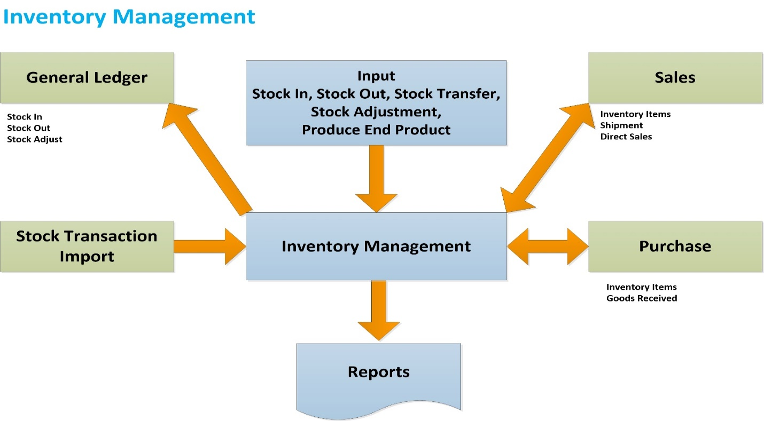

**Fig:** Inventory Management System

# **Why Organization Use Inventory Management**

1. Inventory management is primarily about specifying the shape and percentage of stocked goods.
2. The scope of inventory management concerns the fine lines between replenishment lead time, carrying costs of inventory, asset management, inventory forecasting, inventory valuation, inventory visibility, future inventory price forecasting, physical inventory, available physical space for inventory, quality management, replenishment, returns defective goods and demand forecasting. Balancing these competing requirements leads to optimal inventory levels, which is an on-going process as the business needs shift and react to the wider environment.
3. Management of the inventories, with the primary objective of determining/controlling stock levels within the physical distribution system, functions to balance the need for product availability against the need for minimizing stock holding and handling costs.
4. Inventory management also can help companies improve cash flows. Companies with effective inventory management do not have to spend large capital balances for purchasing enormous amounts of inventory at once. This also saves handling and holding costs.

# **4.0 Functional features of inventory modules are given below**

* Plant Manager or Employee/ Department raises an indent.
* Approval Authority verifies the Indent with necessary information.
* Store Keeper sends all the products according to indent information to Plant Manager or Employer or Department.
* Store Keeper receives goods according to Purchase Order.
* QC Authority checks quality and quantity of goods according to Purchase Order.
* If goods are in good quality and exact quantity then Quality Control (QC) accept goods and update the stock of the goods.
* If goods are not in good condition and not exact quantity, QC Authority returns the rejected goods.
* Store Keeper sends back all rejected goods to Supplier.
* Store Keeper checks all goods and if finds any mismatch then sends the goods to Supplier.
* Transfer Request Authority (Merchandiser / Storekeeper / others) sends request to Approval Authority for item transfer.
* Storekeeper receives request from approval authority for transfer out item from stock.
* Based on approval storekeeper can transfer item from one stock to another stock.
* Storekeeper can issue item to Plant Manager or Employee / Department against indent.
* Plant Manager or Employee / Department can return issued item.
* Storekeeper can adjust the difference item stock in between system and physical.
* Item can be adjusted in case of missing or damaged.

# **5.0 Inventory Process**

* Raise indent process
* Receive goods process
* Receive return process
* Quality Control(QC) process
* Inventory item transfer process
* Issue item process
* Issue return process
* Physical inventory process
* Item adjustment process
* Gate Pass Out Process
* Gate Pass In Process

# **6.0 Process Flow Description**

## **6.1 Raise Indent Process**

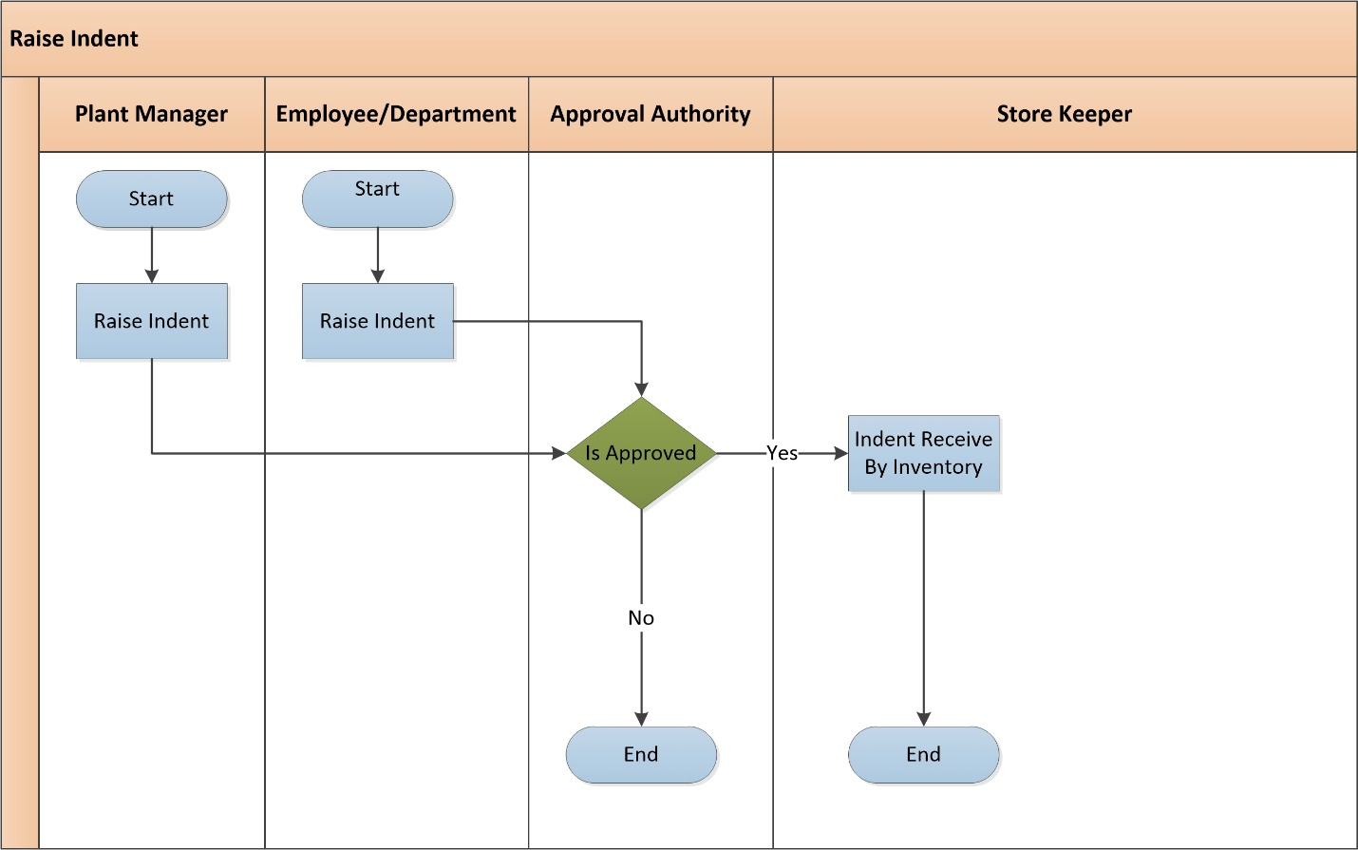

**Fig:** Raise Indent

**Raise Indent Process Description:**

* Plant Manager or Employee/ Department raise indent when they need products for production or Consumption.
* They send the indent to Approval Authority to approve the indent.
* Approval Authority verifies the indent with necessary information. Depending on the approval decision further process is prepared –
  + **Approved:** If approved, then Approval Authority sends the approval message to store keeper to take necessary steps.
  + **Not Approved:** If not approved, then Approval Authority cancels the Indent and stops the Raise Indent Process in the beginning.
* According to approval process, Store Keeper accepts indent information with confirmation message.
* Store Keeper issue stock according to indent information to Plant Manager or Employer or Department.

## **6.2 Receive Goods Process**

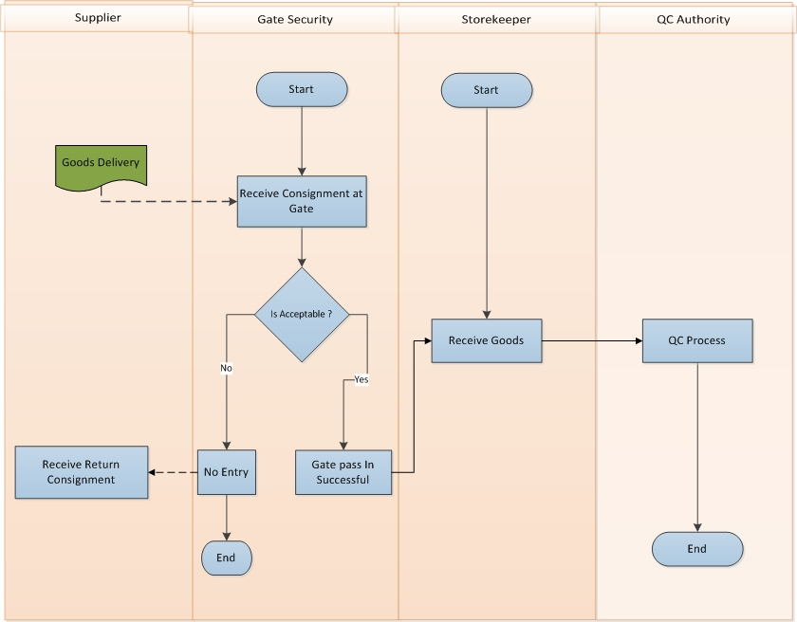

**Fig:** Receive Goods Process

**Receive Goods Process Description**

* Supplier sends goods against Purchase Order (PO) or commercial invoice to requested location.
* Gate Security checks the Consignment according to instruction.
* If consignment is not acceptable then it goes back to supplier.
* If consignment is acceptable then gate security will pass it to Storekeeper
* Store Keeper receives goods from gate security.
* Store Keeper confirms his acceptance as per Purchase Order (PO) and sends all goods to quality control (QC) authority for proper quality control check.
* QC Authority receives all goods and ends the receive goods process.

## **6.3 Receive Return Process**

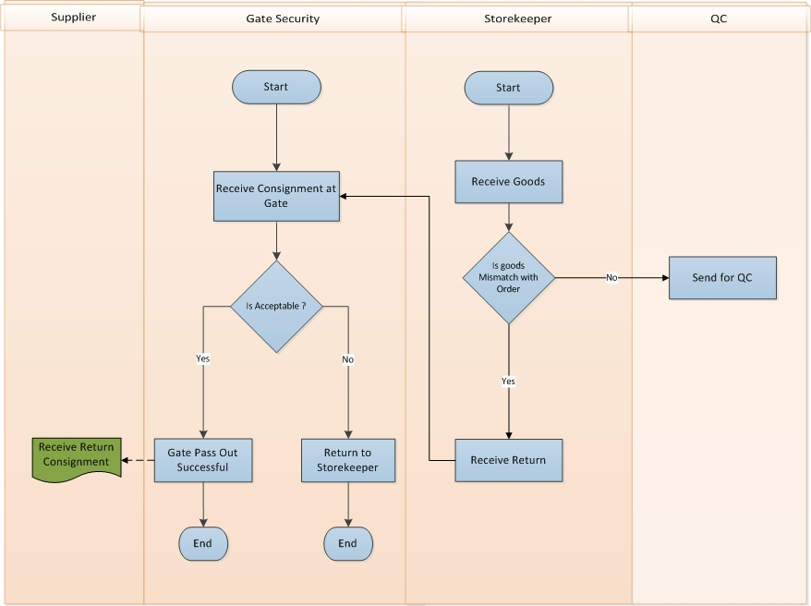

**Fig:** Receive Return Process

**Receive Return Process Description**

* Store Keeper checks all received goods.
* If there is any mismatch in goods against the order then storekeeper sends the goods back to supplier for further action.
* Gate Security gets the request to receive return goods to Supplier.
* If Gate Security accepts the gate pass out request then the consignment goes back to Supplier
* If Gate Security don’t accept the gate pass out request then the consignment goes back to storekeeper again.

## **6.4 Quality Control (QC) Process**

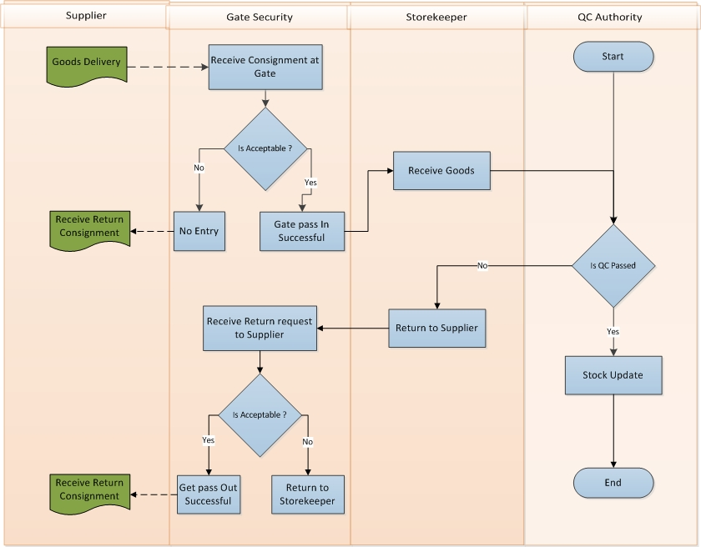

**Fig:** Quality Control (QC) Process (needs to be changed)

**QC Process Description**

* Supplier sends goods against Purchase Order or Commercial Invoice to requested location.
* Gate Security checks the Consignment.
* If Consignment is not acceptable then it goes back to supplier.
* If consignment is acceptable then gate security pass it to storekeeper.
* Store Keeper receives goods.
* Store Keeper confirms his acceptance as per order and sends all goods to QC Authority for proper quality control.
* QC Authority checks the quality and quantity of goods as per Order. According to QC result they take necessary decision-
  + **QC Passed:**
    - If goods are in good quality and exact quantity and Quality then QC accept goods and update the stock of the goods.(According to bappi bhai it should be updated by storekeeper).
  + **QC Failed:**
    - If goods are not acceptable and not in exact quantity, QC Authority returns the rejected goods to Store Keeper for receive return to Supplier.(Figure should be changed)
* Store Keeper receives all rejected goods which were sent by QC Authority and sends the goods back to Supplier for further action
* Gate Security receives the request to Receive Return goods to Supplier
* If Gate Security accept the gate pass out request then the consignment goes back to Supplier
* If Gate Security don’t accept the gate pass out request then the consignment goes back to storekeeper again.(process description will change according to image)

## **6.5 Inventory Item Transfer Process**

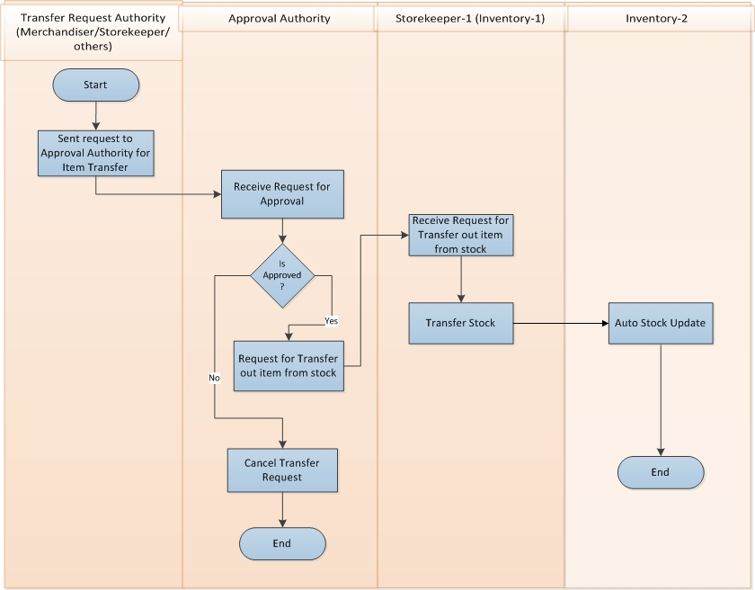

**Fig:** Inventory Item Transfer Process

**Inventory Item Transfer Process Description**

* Transfer Request Authority (Merchandiser/ others) send request to Approval Authority for item transfer.
* Approval Authority receives request for approval from Transfer Request Authority.
* If Approval Authority is not approved then cancel the transfer request.
* If Approval Authority is approved then request goes to storekeeper (inventory-1) for transfer out item from stock.
* Storekeeper-1 (inventory-1) receives request from approval authority for transfer out item from stock.
* Storekeeper-1 (inventory-1) transfer the Item Stock from inventory to Invenory-2.
* Stock goes auto updated in Inventory-2.

## **6.6 Issue Item Process**

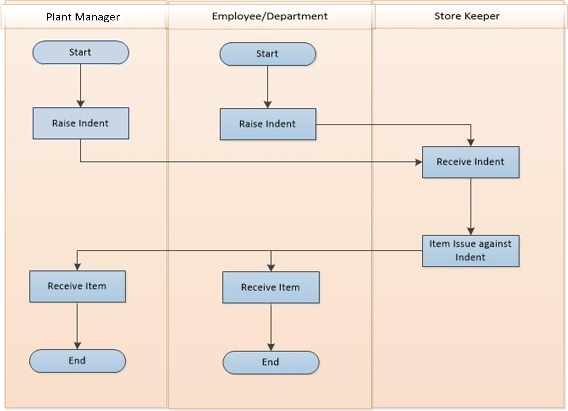

**Fig:** Issue Item Process (Store keeper should update the stock)

**Issue Item Process Description**

* Plant Manager or Employee / Department raises an indent for production or consumption process.
* Storekeeper receives indent from Plant Manager or Employee / Department.
* Storekeeper issue items to Plant Manager or Employee / Department against their raised indent.
* Plant Manager or Employee / Department receives issued item against the indent.

## **6.7 Issue Return Process**

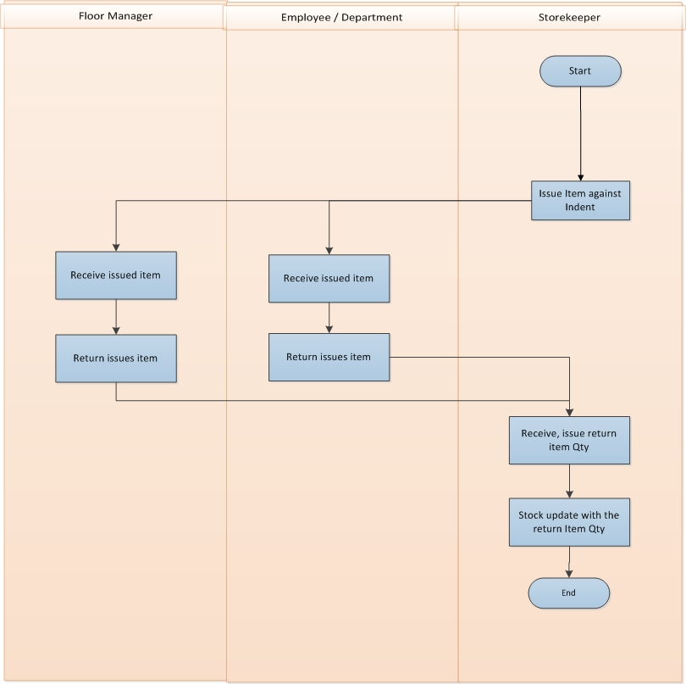

**Fig:** Issue Return Process

**Issue Return Process Description**

* Storekeeper issue item to Plant Manager or Employee / Department against indent.
* Plant Manager or Employee / Department receive issued item against their indent.
* Plant Manager or Employee / Department can return issued item if they are not using all item.
* Storekeeper receives return item from Plant Manager or Employee / Department.
* Storekeeper updates their stock with the return items.

## **6.8 Physical Inventory Process**

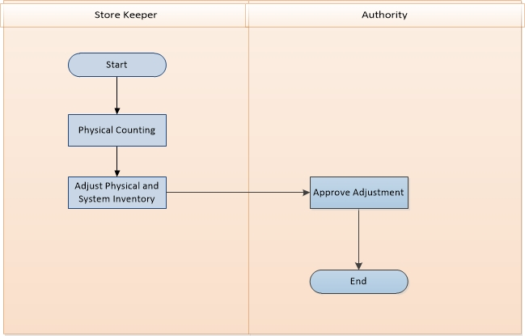

**Fig:** Physical Inventory Process

**Physical Inventory Process Description**

* Storekeeper will count all the item stock physically.
* Storekeeper adjusts the difference item stock in between system and physical stock.
* Authority approves the item adjustment between system and physical stock.

## **6.9 Item Adjustment Process**

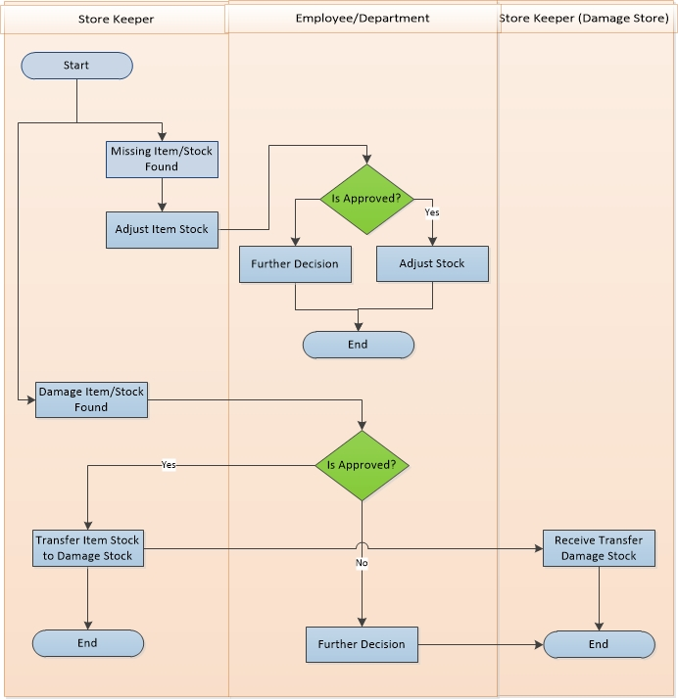

**Fig:** Item Adjustment Process (need to change the diagram is approved check)

**Item Adjustment Process Description**

* Store Keeper adjusts their item/stock depending on various conditions.
  + **Case 1:** Missing item/stock
    - If Store Keeper found any missing item/stock, Store Keeper sends adjustment request to Authority.
    - Authority takes decision depending on some condition. If it approves the request then stock will adjust otherwise they take further decision.
  + **Case 2:** Damage item/stock
    - If Store Keeper found any damage item/stock, Store Keeper sends damage item and make a request to Authority.
    - Authority takes decision depending on some condition. If it approves the request store keeper will be notified and do its further action.
    - Store Keeper sends damage item to Store Keeper (Damage Store) for taking action.
    - If cancel the request then Authority takes further decision.

## **6.10 Gate Pass out Process**

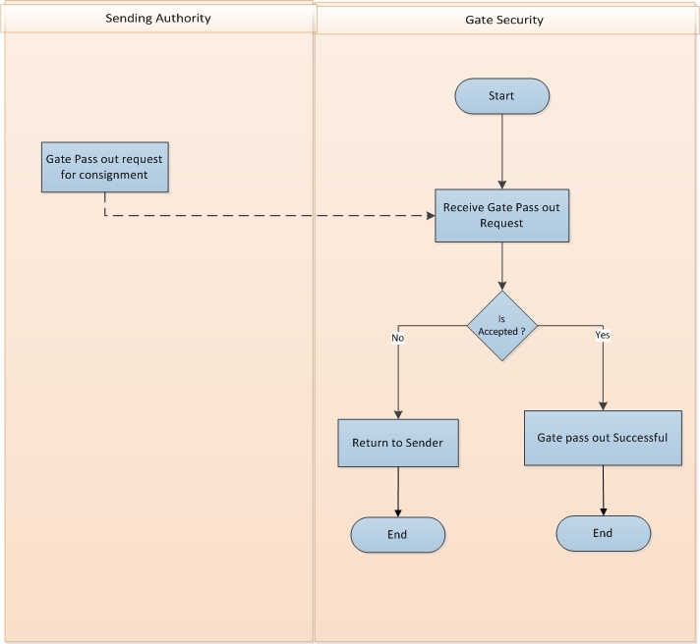

**Fig:** Gate Pass Out

**Gate Pass Out Process Description**

* Sending Authority request for gate pass out to send consignment outside.
* Gate Security check the request from sending authority.
* If the consignment is accepted to pass the gate then gate pass out request will be successful.
* If the consignment is not accepted to pass the gate then consignment will be returned to the sender.

## **6.11 Gate Pass In Process**

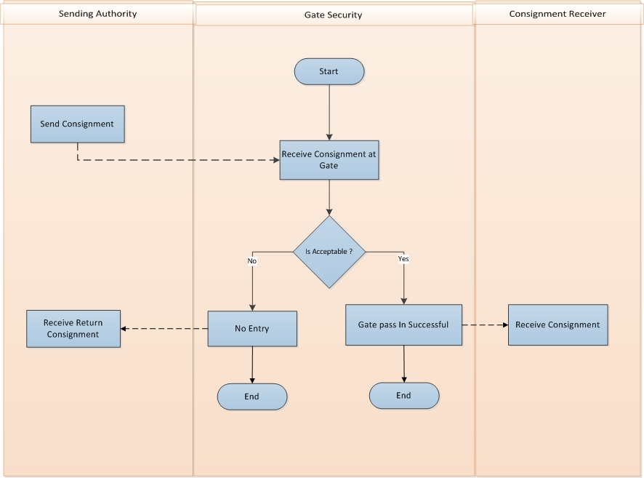

**Fig:** Gate Pass In Process (left end process should be removed)

**Gate Pass In Process Description**

* Sending Authority sends Consignment.
* Gate Security checks the consignment.
* If the consignment is accepted then gate pass in request will be successful.
* Receiver will receive the goods inside the mentioned location.
* If the consignment is not accepted then consignment will not get entered in mentioned location.
* Consignment will be returned to the Sender.

# **7. Appendix**

Some Forms of Samuda maintain for its inventory system.

1.

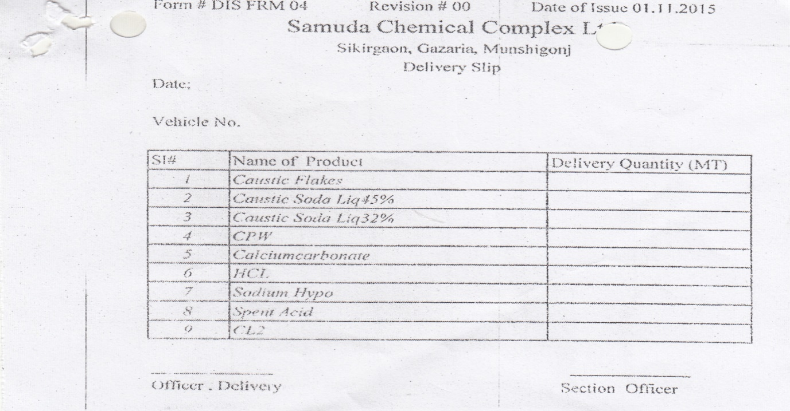

2.

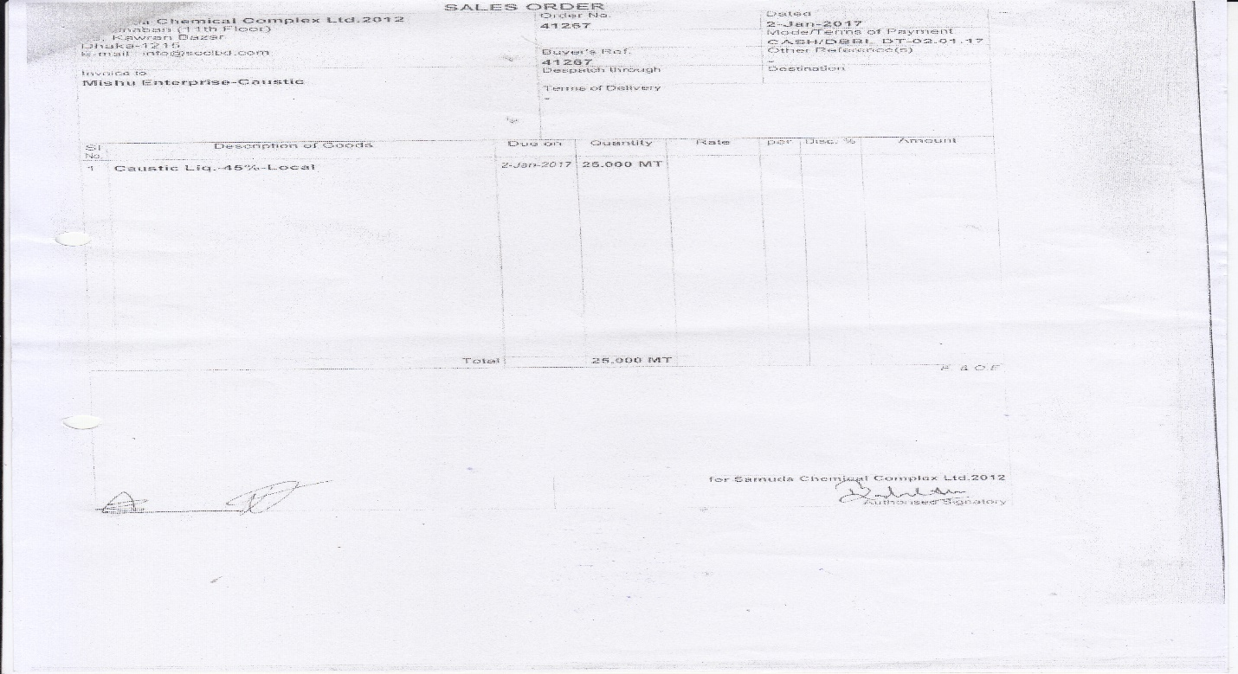

3.

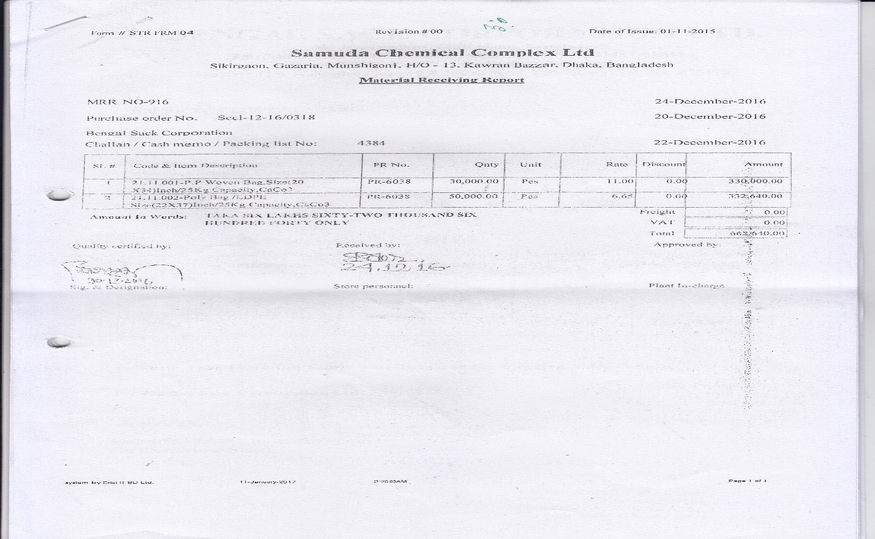

4.

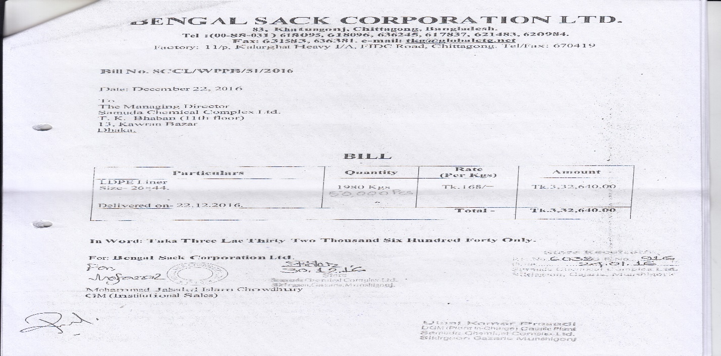

5.

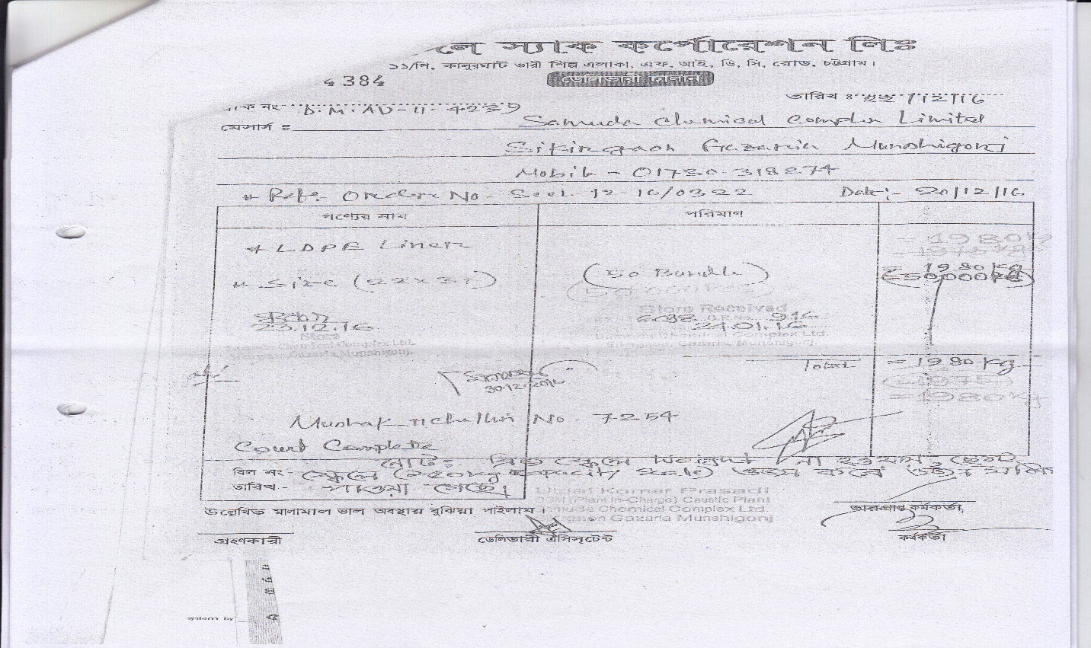

6.

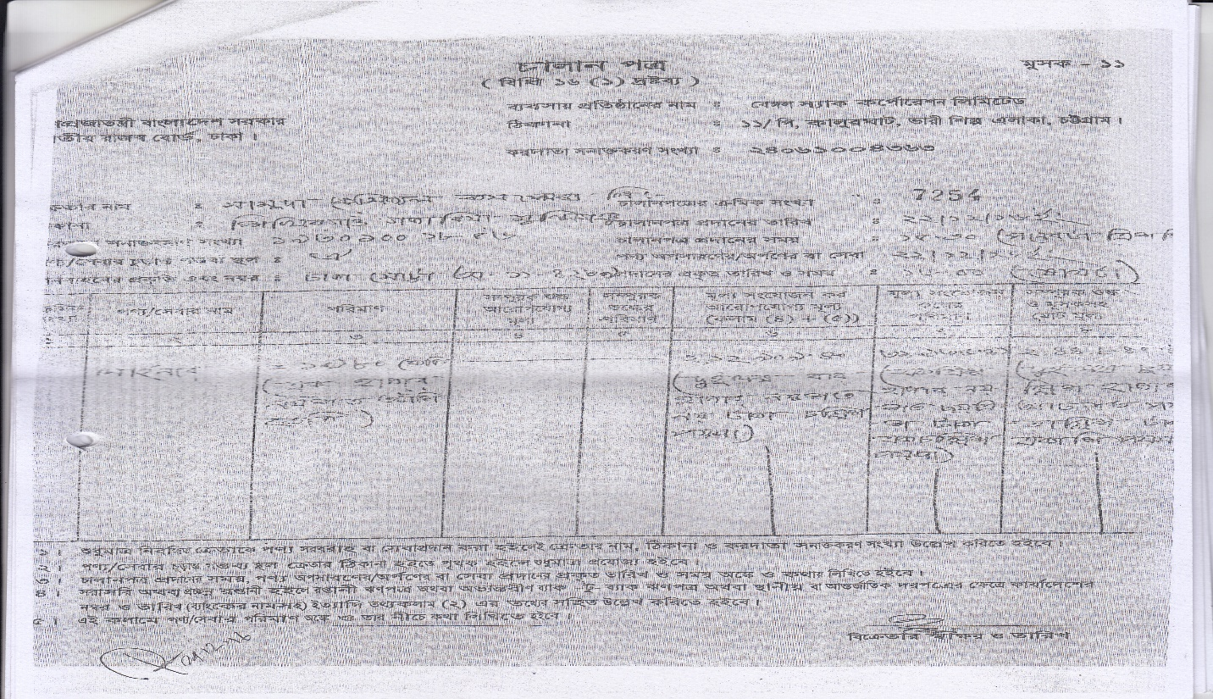

7.

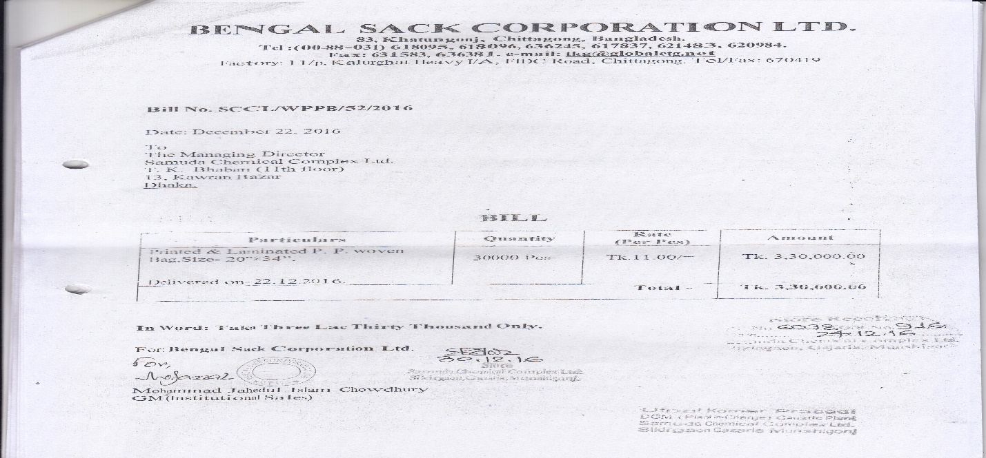

8.

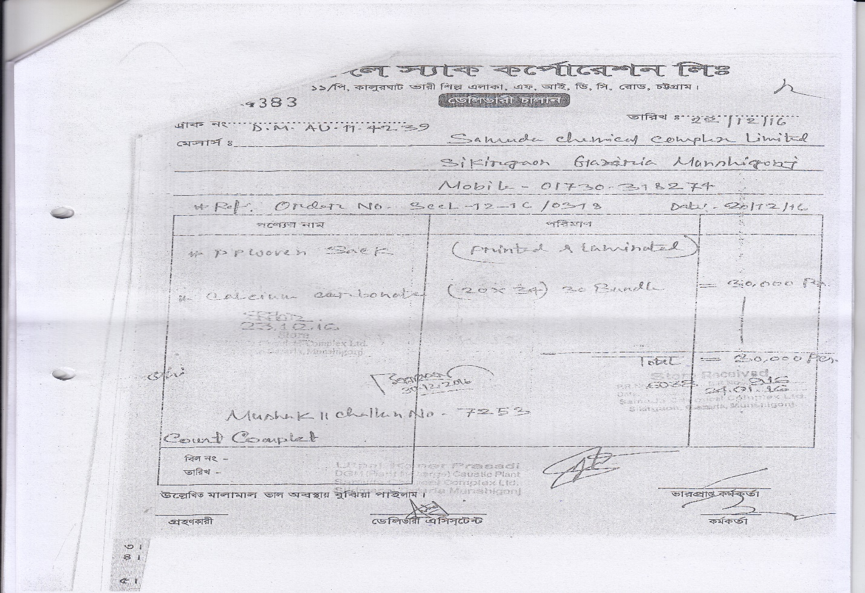

9.

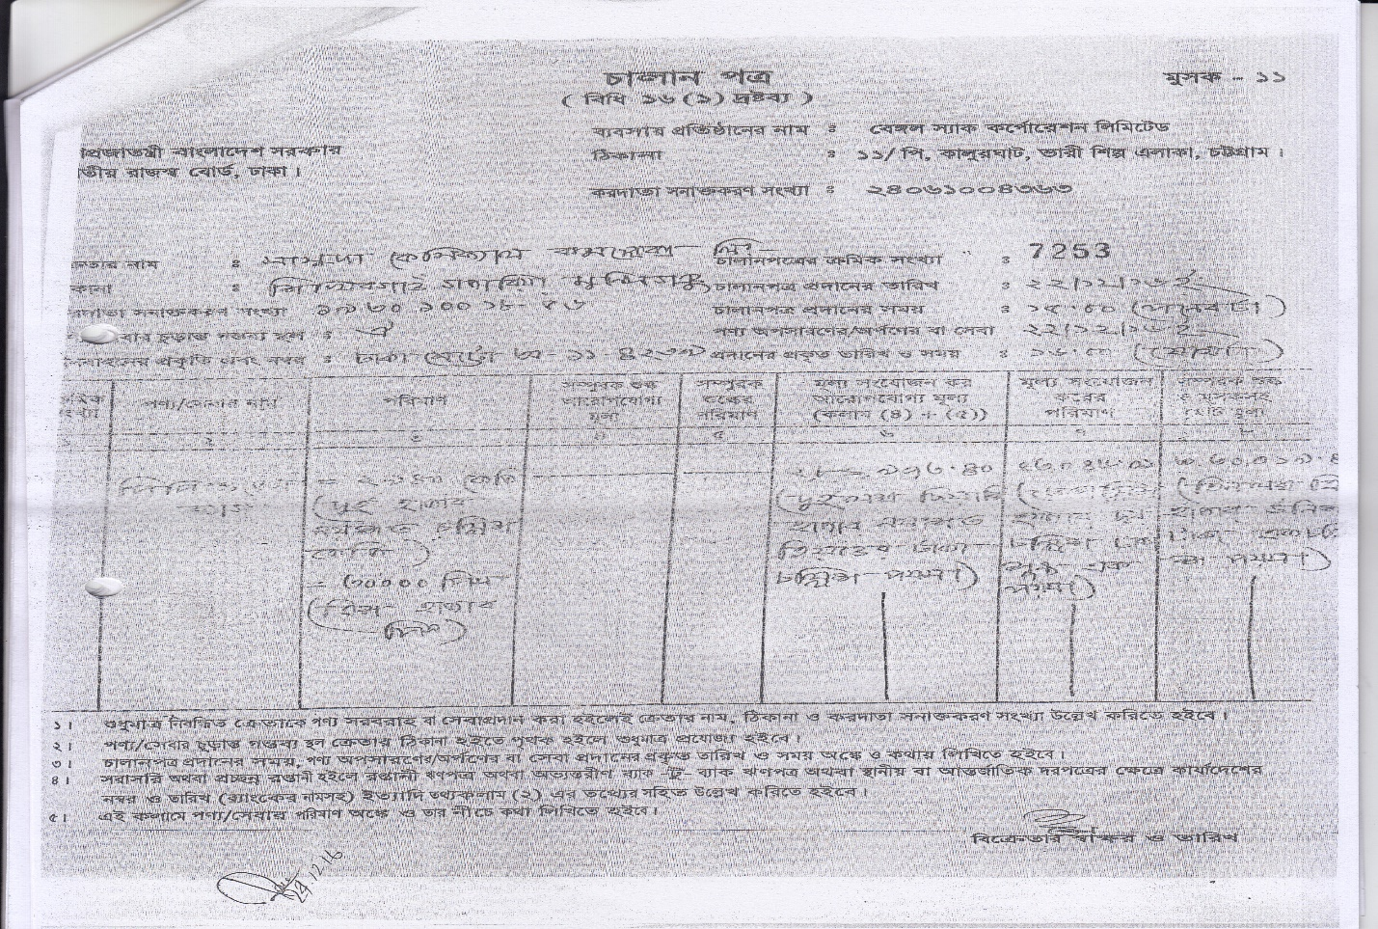

10.

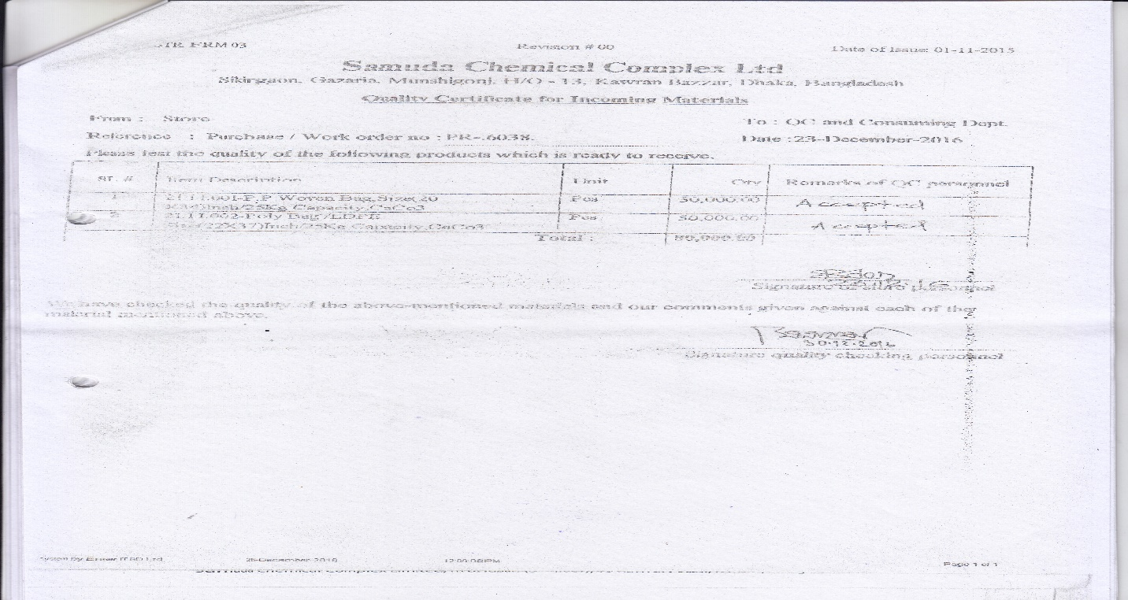

11.

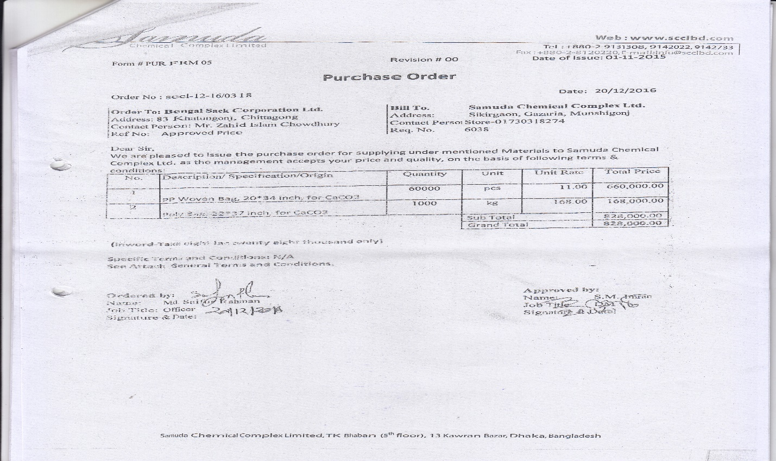

12.

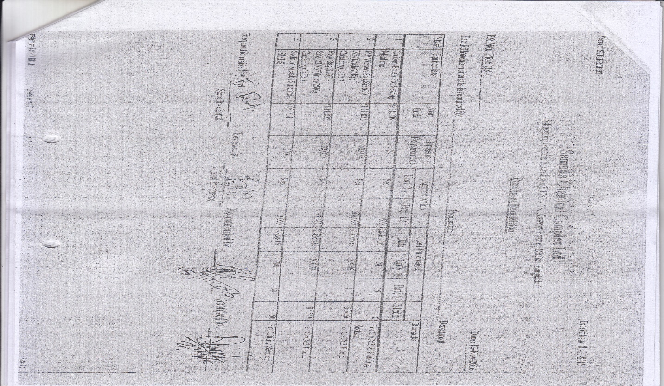

# **8. To be Determined**

1. ISO 9001 related reports are not implemented within this phase. We will cover in next phase.

Signed on behalf of Signed on behalf of

Samuda Chemicals Ltd. Genweb2 Limited

Name: Name:

Designation: Designation:

Date: Date:

**______________________________ ______________________________**

Signature Signature